Cervical Cancer Prediction Using
Machine Learning
A Project Report submitted in the partial fulfillment for the Requirements
for the award of the degree

MASTER OF COMPUTER APPLICATIONS

Submitted by

Mr. SIKHAKOLANU DEEPAK NAGA SAI

(24471F0096)
Under the esteemed guidance of
Mrs. M. Mounika Naga Bhavani, _{M. TECH}
Assistant Professor



DEPARTMENT OF MASTER OF COMPUTER APPLICATIONS

NARASARAOPETA ENGINEERING COLLEGE: NARASARAOPET
(AUTONOMOUS)
Accredited by NAAC with A+ Grade and NBA under Tier -1
and an ISO 9001:2015 Certified
Approved by AICTE, New Delhi, Permanently Affiliated to JNTUK, Kakinada
KOTAPPAKONDA ROAD, YELLAMANDA VILLAGE, NARASARAOPET, 522601
2025-2026

Cervical Cancer Prediction using
Machine Learning

BY
MR. S. DEEPAK NAGA SAI
(24471F0096)

Plagiarism Report:
___________________________________________
Submission date: Apr 27, 2026, 9:37 AM GMT+5:30
Submission ID: 3551783758
File name: 24471F0096_Document.pdf
Word count: 7,610
Character count: 44,082
Similarity Index: 43%

NARASARAOPETA ENGINEERING COLLEGE: NARASARAOPET

(AUTONOMOUS)

DEPARTMENT OF MASTER OF COMPUTER APPLICATIONS


CERTIFICATE

This is to certify that the project work entitled “Cervical Cancer Prediction using Machine Learning” is being submitted by Mr. Sikhakolanu Deepak Naga Sai (24471F0096) as a partial fulfillment of the requirements for the award of MASTER OF COMPUTER APPLICATIONS degree of JNTUK, Kakinada during December 2025 – April 2026 under my supervision and found worth of acceptance to requirements of the university.

PROJECT GUIDE PROJECT CO-ORDINATOR
Mrs. M. Mounika Naga Bhavani, M.Tech Mr.G. Ravi PurnaChandra Rao,Mca
Assistant Professor Assistant Professor

HEAD OF THE DEPARTMENT EXTERNALEXAMINER
Dr. K. LakshmiNadh, M.Tech., Ph.D.
Professor & HoD
PRINCIPAL
Dr. S. Venkateswarlu, _{M.E., Ph.D}

DECLARATION

I here by declare that this project work titled “Cervical Cancer Prediction using Machine Learning” is a bonafied work carried out by me under the guidance and supervision of Mrs.A. Aruna Kumari, Mca, Assistant Professor, Dept of MCA, Narasaraopeta Engineering College, for the award of Master of Computer Applications degree of Jawaharlal Nehru Technological University Kakinada. This work has not been submitted to any other University/Institution for the award of any degree.

Mr. S. Deepak Naga Sai
(24471F0096)

ACKNOWLEDGEMENT
I wish to express my heartfelt gratitude to all those who have supported and guided me throughout the successful completion of this work.
First and foremost, I am deeply grateful to our esteemed Chairman, Sri M.V. Koteswara Rao, _{B.Sc}., whose unwavering encouragement and continuous support have been instrumental throughout my academic journey.
I would like to extend my sincere thanks to our respected Principal, Dr. S. Venkateswarlu, _{M.E., Ph.D}., for his valuable guidance and encouragement, which have greatly contributed to my growth and learning.
My deepest appreciation goes to Dr. K. Lakshmi Nadh, _{M.Tech., Ph.D}., Professor and Head of the MCA Department, whose insight and leadership have provided the foundation for academic excellence. I also express my sincere thanks to my project guide, Mrs. M. Mounika Naga Bhavani, _{M. Tech}, Assistant Professor, for her patient guidance, invaluable suggestions, and constant motivation throughout the course of this project.
I am especially thankful to Mr. G. Ravi Purna Chandra Rao, _{MCA}, Assistant Professor and Project Coordinator, for his support, constructive feedback, and encouragement, which have been a constant source of inspiration during this work.
I extend my appreciation to the faculty and staff of the MCA Department for their ongoing support, insightful discussions, and encouragement, which have enriched my learning experience..
Finally, I thank my friends and peers for their helpful suggestions, collaboration, and moral support, all of which have contributed meaningfully to the successful completion of this work.
By
Mr. S. Deepak Naga Sai
(24471F0096)

ABSTRACT
Cervical cancer is one of the most common and life-threatening cancers affecting women worldwide, especially in developing countries. Early detection of cervical cancer plays a crucial role in reducing mortality rates and improving the survival chances of patients. Traditional diagnostic methods such as Pap smear tests and biopsies are time-consuming, costly, and highly dependent on medical expertise. Hence, there is a need for an automated and accurate system to assist in early diagnosis.
This project, titled “Cervical Cancer Prediction Using Machine Learning”, aims to develop an efficient machine learning-based system to predict the occurrence of cervical cancer using medical and demographic data. The proposed system uses a publicly available cervical cancer dataset containing various risk factors such as age, number of pregnancies, sexual behavior, and medical history. The dataset is preprocessed to handle missing values and improve data quality.
Machine learning algorithms are trained on the processed dataset to classify whether a patient is likely to have cervical cancer or not. The performance of the system is evaluated using metrics such as accuracy, precision, recall, and confusion matrix. The experimental results show that machine learning techniques can provide reliable and accurate predictions, thereby assisting medical professionals in early diagnosis and decision-making.
The proposed system is cost-effective, efficient, and can be used as a supportive tool in healthcare environments. This project demonstrates the potential of machine learning in medical diagnosis and highlights its importance in improving healthcare services.

S.NO  1 | INDEX  CONTENT  INTRODUCTION | PAGE NO  1
 | 1.1 Objectives of the Project | 1
 | 1.2 Scope of the Project | 2
2 | LITERATURE SURVEY | 4
3 | SYSTEM ANALYSIS | 9
 | 3.1 Existing System | 9
 | 3.1.1 Disadvantages of Existing System | 9
 | 3.2 Proposed System | 9
 | 3.2.2 Advantages of Proposed System | 11
 | 3.3 Feasibility Study | 12
 | 3.3.1 Technical Feasibility | 12
 | 3.3.2 Economic Feasibility | 12
 | 3.3.3 Social Feasibility | 12
 | 3.4 System Flow Diagram | 13
4 | SYSTEM REQUIREMENTS | 14
 | 4.1 Software Requirements | 14
 | 4.2 Hardware Requirements | 15
 | 4.3 Functional Requirements | 15
 | 4.4 Non-Functional Requirements | 15
 | 4.5 Software Description | 16
 | 4.5.1 Machine Learning | 16
 | 4.5.2 Types of Machine Learning | 16
 | 4.5.3 Need for Machine Learning in ‎ ‎‎ ‎ ‎ ‎ ‎ ‎ ‎ ‎ ‎ ‎Healthcare | 17
 | 4.5.4 Challenges in Machine Learning | 17
 | 4.6 Algorithms | 18
 | 4.6.1 Logistic Regression | 18
 | 4.6.2 Random Forest | 18
 | 4.6.3 Support Vector Machine | 18
 | 4.6.4 Naive Bayes | 18
 | 4.6.5 XGBoost | 18
5 | SYSTEM DESIGN | 20
5.1 | 5.1 Introduction | 20
5.2 | 5.2 System Architecture | 20
5.3 | 5.3 System Modules | 21
5.4 | 5.4 UML Diagrams | 22
 | 5.4.1 Use Case Diagram | 22
 | 5.4.2 Activity Diagram | 23
 | 5.4.3 Sequence Diagram | 24
 | 5.4.4 Class Diagram | 25
 | 5.4.5 Data Flow Diagram | 26
6 | IMPLEMENTATION | 27
 | 6.1 Introduction | 27
 | 6.2 Dataset Description | 27
 | 6.3 Data Preprocessing | 27
 | 6.4 Feature Selection | 28
 | 6.5 Model Training | 28
 | 6.6 Implementation Steps | 28
 | 6.7 Model Evaluation | 29
 | 6.8 Code | 29
7 | TESTING | 32
 | 7.1 Introduction | 32
 | 7.2 Types of Testing | 32
 | 7.2.1 Unit Testing | 32
 | 7.2.2 Integration Testing | 32
 | 7.2.3 System Testing | 32
 | 7.3 Performance Testing | 32
 | 7.4 Test Cases | 33
 | 7.5 Evaluation Metrics | 33
8 | OUTPUT SCREENS | 35
 | 8.1 Dataset Loading Screen | 35
 | 8.2 Data Preprocessing Output | 36
 | 8.3 Model Training Output | 37
 | 8.4 Prediction Result Screen | 38
9 | CONCLUSION | 41
10 | FUTURE SCOPE | 42
11 | REFERENCES | 43

FIG NO | FIGURE CAPTION / TABLE CAPTION | PAGE NO
1.1 | Overview of Cervical Cancer Prediction Using Machine Learning | 2
3.2.1 | Machine Learning Workflow for Cervical Cancer Prediction | 10
3.4.1 | System Flow Diagram | 13
4.1.1 | Software Requirements for Cervical Cancer Prediction System | 14
4.5.2.1 | Supervised Learning Diagram | 16
4.5.2.2 | Unsupervised Learning Diagram | 16
4.5.2.3 | Reinforcement Learning Diagram | 17
4.6.4.1 | Naïve Bayes Formula | 18
5.2.1 | System Architecture for Cervical Cancer Prediction | 20
5.4.1.1 | Use Case Diagram for Cancer Prediction System | 22
5.4.2.1 | Activity Diagram for Cancer Prediction System | 23
5.4.3.1 | Sequence Diagram for Cancer Prediction System | 24
5.4.4.1 | Class Diagram for Cancer Prediction System | 25
5.4.5.1 | Data Flow Diagram (DFD) for Cancer Prediction System | 26
7.4.1 | Test Cases for Cancer Prediction System | 33
7.2.5.1 | Confusion Matrix for Model Evaluation | 34
8.1.1 | Dataset Loading Screen | 35
8.2.1 | Data Preprocessing Output | 36
8.3.1 | Model Training Output | 37
8.4.1 | Empty Output Screen | 38
8.4.2 | Predicted Output Screen | 39

1. INTRODUCTION
Cervical cancer is a type of cancer that develops in the cervix, which is the lower part of the uterus connecting to the vagina. It is one of the leading causes of cancer-related deaths among women globally [1]. Cervical cancer usually develops slowly and may not show symptoms in its early stages, making early detection difficult. If detected at an early stage, cervical cancer can be treated effectively and survival rates can be significantly improved.
In recent years, advancements in medical technology and data analysis have enabled the use of computational techniques for disease prediction [2]. Machine learning is a branch of artificial intelligence that allows systems to learn patterns from data and make predictions without being explicitly programmed [3]. The application of machine learning in healthcare has gained significant attention due to its ability to analyze large and complex datasets efficiently [4].
This project focuses on applying machine learning techniques to predict cervical cancer by analyzing patient risk factors. By using machine learning models, the system can assist doctors in identifying high-risk patients at an early stage.
Traditional methods for diagnosing cervical cancer involve clinical tests such as Pap smear tests, HPV tests, and biopsies [5]. These methods require specialized equipment, skilled professionals, and considerable time for diagnosis. In many cases, delayed diagnosis leads to the progression of the disease, reducing the chances of successful treatment.
Additionally, manual diagnosis may lead to human errors due to fatigue or misinterpretation of test results. There is a need for an automated system that can analyze patient data efficiently and provide accurate predictions to support medical professionals [6].
The problem addressed in this project is to design and implement a machine learning-based system that can predict cervical cancer using patient data, thereby reducing diagnostic time, cost, and dependency on manual analysis.

1.1 Objectives of the Project
The main objectives of this project are:
- To study and analyze cervical cancer risk factors
- To design a machine learning-based prediction system
- To preprocess and analyze the cervical cancer dataset
- To train and evaluate machine learning models for prediction
- To improve early detection and decision-making in healthcare

1.2 Scope of the Project
The scope of this project is limited to predicting the presence of cervical cancer using historical medical and demographic data. The system acts as a decision-support tool and does not replace medical diagnosis. The project demonstrates how machine learning techniques can be effectively applied in the healthcare domain to assist doctors and medical practitioners.
Future enhancements may include the integration of deep learning models, real-time hospital data, and deployment as a web or mobile application for broader accessibility.

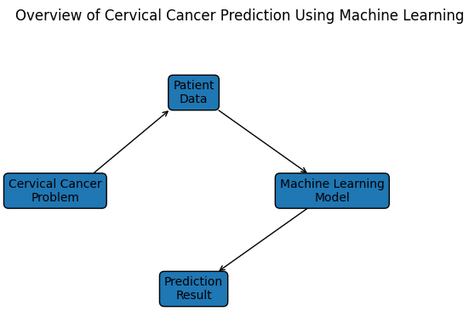
Figure 1.1 Overview of Cervical Cancer Prediction Using Machine Learning
Figure 1.1 The diagram titled “Overview of Cervical Cancer Prediction Using Machine Learning” illustrates the basic workflow of predicting cervical cancer using machine learning techniques. It presents a simple step-by-step process that begins with identifying the cervical cancer problem and ends with generating a prediction result.
The first component in the diagram is Cervical Cancer Problem, which represents the medical challenge of detecting cervical cancer at an early stage. Early detection is very important because it helps doctors provide timely treatment and improves patient survival rates.
Next, the process moves to Patient Data. This includes medical information collected from patients such as age, medical history, HPV infection status, lifestyle factors, and results from medical tests. These data points are essential for training and evaluating machine learning models.
The collected patient data is then provided to the Machine Learning Model. In this stage, algorithms analyze patterns within the data and learn relationships between different medical factors and the occurrence of cervical cancer. Common algorithms may include decision trees, random forests, or logistic regression.
Finally, the model produces a Prediction Result, which indicates whether a patient is likely to have cervical cancer or not. This result can assist healthcare professionals in making better diagnostic decisions and improving early screening programs.

2. LITERATURE SURVEY
Title 1: CerviFormer: Pap-Smear Based Cervical Cancer Classification
Author(s): Bhaswati Singha Deo et al.
Year: 2023
Summary: This paper presents a transformer-based deep learning model called CerviFormer for cervical cancer detection using Pap smear images [7]. The model uses attention mechanisms to capture complex features from medical images. It improves classification performance compared to traditional CNN models. The approach achieves high accuracy and demonstrates the effectiveness of transformer architectures in healthcare.
Advantages:
- High accuracy with deep learning.
- Works well on image data.
- Advanced transformer architecture.
Disadvantages:
- Requires large dataset.
- High computational cost.

Title 2: Cervical Cancer Prediction Using Machine Learning
Author(s): Rashmi Ashtagi et al.
Year: 2024
Summary: This study applies machine learning algorithms such as Random Forest, SVM, and Logistic Regression for cervical cancer prediction [8]. It uses patient risk factors like age, smoking, and medical history. The results show that ensemble methods provide better accuracy compared to single models. The study highlights the importance of feature selection in improving performance.
Advantages:
- Uses real-world clinical data.
- Good accuracy with multiple models.
Disadvantages:
- Limited dataset size.
- Feature dependency.

Title 3: Cervical Cancer Prediction Based on Imbalanced Data
Author(s): M.M. Muraru et al.
Year: 2024
Summary: This paper focuses on handling imbalanced datasets in cervical cancer prediction [9]. It uses SMOTE and other resampling techniques to balance the data. The study improves classification performance by reducing bias toward majority classes. It also evaluates different machine learning models under balanced conditions.
‎ ‎ ‎ ‎ Advantages:
- Handles imbalance problem.
- Improves accuracy.
Disadvantages:
- Risk of overfitting.
- Complex preprocessing.

Title 4: Comparative Study on ML Classifiers for Cervical Cancer
Author(s): Various.
Year: 2024
Summary: This research compares different machine learning algorithms for cervical cancer prediction [10]. Models such as SVM, Decision Tree, and Naive Bayes are evaluated. The results show that SVM achieves the highest accuracy among all models. The study provides insights into selecting suitable algorithms for prediction tasks.
Advantages:
- High accuracy models.
- Comparative analysis.
Disadvantages:
- Overfitting risk.
- Limited generalization.

Title 5: Interpretable AI for Cervical Cancer Prediction
Author(s): P. Roy et al.
Year: 2025
Summary: This paper introduces explainable AI techniques for cervical cancer prediction [11]. It uses models that provide feature importance and decision transparency. The approach helps doctors understand the reasoning behind predictions. It improves trust and usability of machine learning systems in healthcare.
Advantages:
- Transparent predictions.
- Better decision-making.
Disadvantages:
- Slightly lower accuracy.
- Increased complexity.

Title 6: Deep Learning Methods for Cervical Cancer Detection
Author(s): P. Patre et al.
Year: 2025
Summary: This study reviews deep learning methods such as CNN and transfer learning [12]. It explains how image-based detection improves early diagnosis of cervical cancer. Data augmentation techniques are used to enhance model performance. The paper highlights the importance of deep learning in medical imaging.
Advantages:
- High Performance.
- Suitable for image data.
Disadvantages:
- Needs large Dataset.
- High Training Time.

Title 7: ML-Based Prediction of Clinical Outcomes
Author(s): G. Bai et al.
Year: 2025
Summary: This research uses machine learning models to predict clinical outcomes in cervical cancer patients [13]. It analyzes patient data such as lab results and medical history. The model helps in predicting disease progression and survival rates. It supports doctors in making better treatment decisions.
Advantages:
- Useful for prognosis.
- Real-world application.
Disadvantages:
- Data Quality Issues.
- Limited Scalability.

Title 8: ML Models for Cervical Cancer Risk Prediction
Author(s): J. Su et al.
Year: 2025
Summary: This paper develops machine learning models for predicting cervical cancer risk [14]. It uses SHAP values to explain model predictions. The approach identifies important features influencing the results. It improves both accuracy and interpretability of the system.
Advantages:
- Explainable results.
- Feature importance analysis.
Disadvantages:
- Computationally expensive
- Requires expertise.

Title 9: Federated Learning for Cervical Cancer Prediction
Author(s): S. Singla et al.
Year: 2025
Summary: This study introduces federated learning for privacy-preserving cervical cancer prediction [15]. It allows multiple institutions to train models without sharing data. Blockchain technology is used to enhance security. The model achieves high accuracy while maintaining data privacy.
Advantages:
- Ensures privacy.
- High accuracy.
Disadvantages:
- Complex system
- Infrastructure requirement.

Title 10: AI-Based Prediction Using Imaging and Clinical Data
Author(s): M. Zhang et al.
Year: 2025
Summary: This paper combines imaging data and clinical information for cancer prediction. Machine learning models such as SVM are used for classification. The system improves prediction accuracy by using multiple data sources [16]. It demonstrates the benefits of multi-modal data integration.
Advantages:
- Better accuracy.
- Uses multiple data sources.
Disadvantages:
- Complex Design.
- High Computation.

3. SYSTEM ANALYSIS
3.1 Existing System
In the existing system, cervical cancer diagnosis is mainly performed using traditional medical tests such as Pap smear tests, HPV tests, colposcopy, and biopsy [17]. These methods require clinical infrastructure, laboratory facilities, and skilled medical professionals. The diagnosis process is time-consuming and often expensive, making it less accessible in rural and developing regions.
The existing system heavily depends on manual examination and expert interpretation of test results. This may lead to delayed diagnosis and, in some cases, human errors [18]. Additionally, the traditional methods do not efficiently utilize historical patient data for predictive analysis [19].

3.1.1 Disadvantages of Existing System
The disadvantages of the existing system are as follows:
- High cost of diagnostic procedures
- Time-consuming testing and analysis
- Dependency on skilled medical experts
- Possibility of human error
- Limited accessibility in remote areas
- Lack of automated prediction support

3.2 Proposed System
The proposed system is a machine learning-based cervical cancer prediction system that analyzes patient medical and demographic data to predict the likelihood of cervical cancer. The system uses historical data and applies machine learning algorithms to identify patterns and relationships among risk factors.
The proposed system includes data preprocessing, feature selection, model training, and prediction phases. By using machine learning techniques, the system can provide faster and more accurate predictions, supporting healthcare professionals in decision-making.
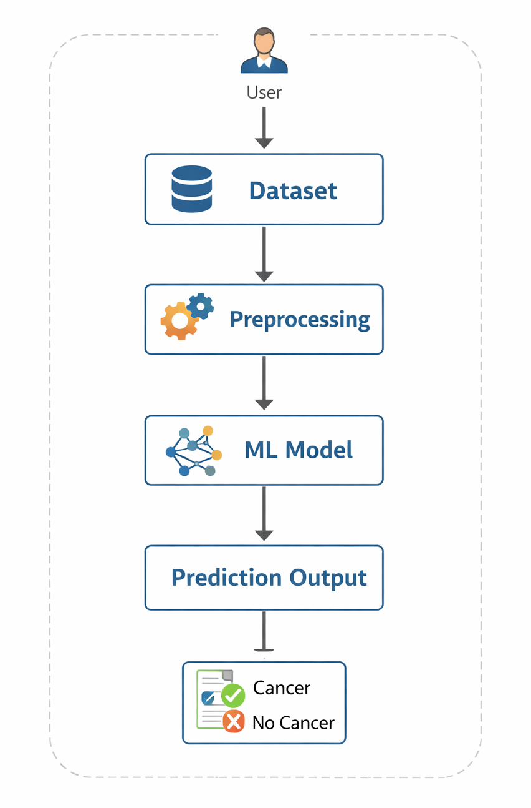
Figure 3.2.1 Machine Learning Workflow for Cervical Cancer Prediction
Figure 3.2.1 The diagram illustrates the workflow of predicting cervical cancer using a machine learning approach. The process begins with the User, who provides or accesses the Dataset containing patient medical information. This dataset then goes through a Preprocessing stage where missing values are handled, irrelevant data is removed, and the data is prepared for analysis. After preprocessing, the cleaned data is fed into the Machine Learning (ML) Model, which learns patterns and relationships from the data. Finally, the system generates a Prediction Output, indicating whether the patient is likely to have Cancer or No Cancer, helping support early detection and medical decision-making.

3.2.2 Advantages of Proposed System
The advantages of the proposed system include:
- Early detection of cervical cancer
- High prediction accuracy
- Reduced diagnosis time
- Cost-effective solution
- Minimizes human error
- Can handle large datasets efficiently
- Acts as a decision support tool for doctors

3.3 Feasibility Study
Feasibility study is conducted to evaluate whether the proposed system is practical and viable for implementation. The feasibility analysis is divided into three categories: technical feasibility, economic feasibility, and social feasibility.
3.3.1 Technical Feasibility
The proposed system is technically feasible as it uses widely available technologies such as Python programming language and machine learning libraries. The implementation is carried out using Google Colab, which provides a free and cloud-based development environment. Machine learning algorithms such as Logistic Regression, Random Forest, and Support Vector Machine are well-supported by existing libraries.
3.3.2 Economic Feasibility
The system is economically feasible as it uses open-source tools and technologies. Python, Google Colab, and machine learning libraries are available free of cost. No additional hardware investment is required, making the system cost-effective and affordable.
3.3.3 Social Feasibility
The proposed system is socially feasible as it aims to improve women’s healthcare by enabling early detection of cervical cancer. The system can assist medical professionals and improve healthcare services, especially in underdeveloped regions. It also raises awareness about the importance of preventive healthcare.

3.4 System Flow Diagram
The system follows the below flow:
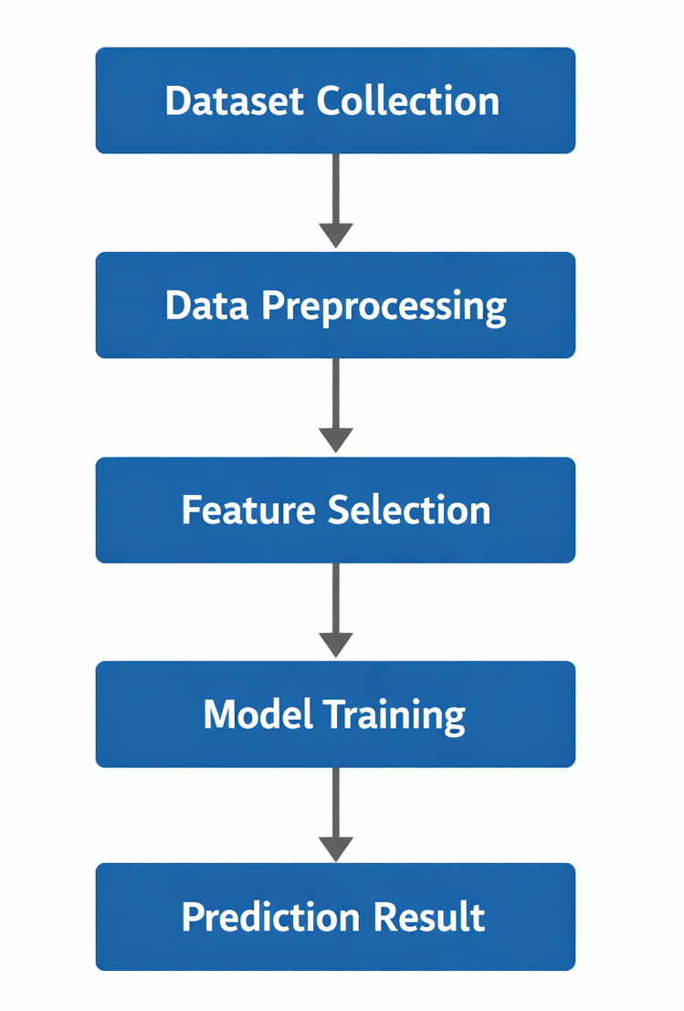
Figure 3.4.1
Figure 3.4.1 The system flow diagram illustrates the overall working process of the cervical cancer prediction system. Initially, the dataset is collected and loaded into the system for analysis. The data preprocessing step cleans the data by handling missing and inconsistent values. Feature selection is then performed to identify the most important attributes influencing cervical cancer prediction.

4. SYSTEM REQUIREMENTS
4.1 Software Requirements
The following software tools are required to develop and implement the proposed system:
- Operating System: Windows / Linux
- Programming Language: Python
- Development Environment: Google Colab
- Libraries:
    - NumPy
    - Pandas
    - Matplotlib
    - Scikit-learn
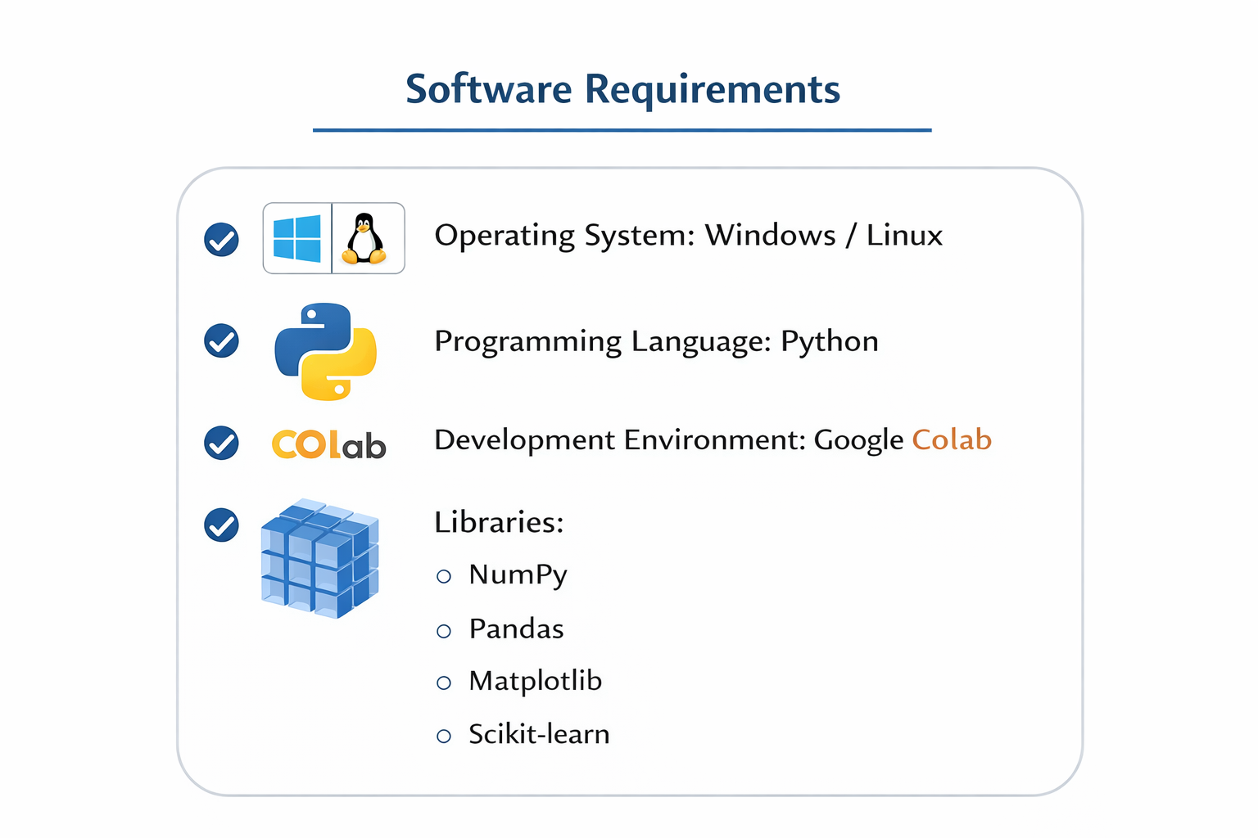
Figure 4.1.1 Software Requirements for Cervical Cancer Prediction System
Figure 4.1.1 The diagram presents the software requirements needed to develop a machine learning system for cervical cancer prediction. It specifies the Operating System as either Windows or Linux, which provides the platform to run the application. The Programming Language used is Python, known for its strong support for data analysis and machine learning tasks. The Development Environment mentioned is Google Colab, which allows users to write and execute Python code in a cloud-based environment. The system also uses several important libraries, including NumPy for numerical operations, Pandas for data handling, Matplotlib for visualization, and Scikit-learn for implementing machine learning algorithms.
Python is chosen due to its simplicity, flexibility, and wide support for machine learning libraries. Google Colab provides a cloud-based platform with pre-installed libraries, making development faster and easier.
4.2 Hardware Requirements
The hardware requirements for the proposed system are minimal:
- Processor: Intel i3/i5 or higher
- RAM: Minimum 4 GB (8GB recommended)
- Storage: 20 GB free disk space
- System Type: 64-bit Operating System
- Internet Connection: Required for cloud-based execution
4.3 Functional Requirements
Functional requirements describe what the system is expected to do.
- The system should load the cervical cancer dataset
- The system should preprocess the dataset
- The system should train machine learning models
- The system should predict cervical cancer occurrence
- The system should display prediction results
4.4 Non-Functional Requirements
Non-functional requirements describe how the system performs.
- Accuracy: High prediction accuracy
- Performance: Fast execution
- Reliability: Consistent results
- Scalability: Ability to handle large datasets
- Usability: Easy to understand and use

4.5 Software Description
4.5.1 Machine Learning
Machine learning is a subset of artificial intelligence that enables systems to learn from data and make predictions without explicit programming. Machine learning algorithms analyze historical data, identify patterns, and use these patterns to predict future outcomes. Machine learning plays a significant role in healthcare by assisting in disease diagnosis and prediction.
4.5.2 Types of Machine Learning
Machine learning can be classified into the following types:
- Supervised_Learning:
Uses labeled data to train models. This project uses supervised learning.
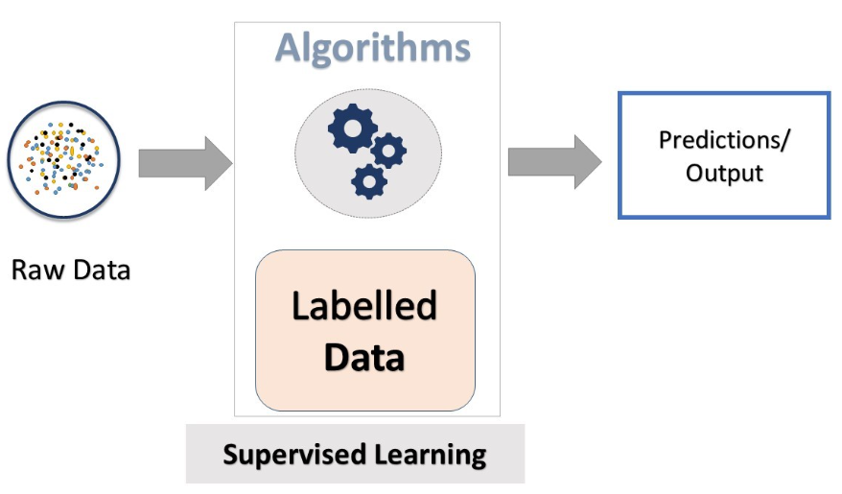
Figure 4.5.2.1 Supervised Learning Diagram

- Unsupervised_Learning:
Works on unlabelled data to find hidden patterns.
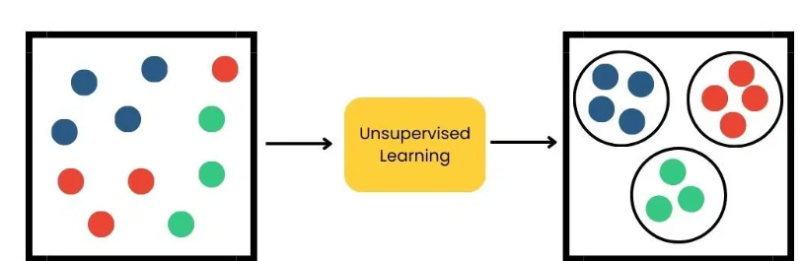
Figure 4.5.2.2 Unsupervised Learning Diagram

- Reinforcement Learning :
Learns by interacting with the environment using rewards and penalties. 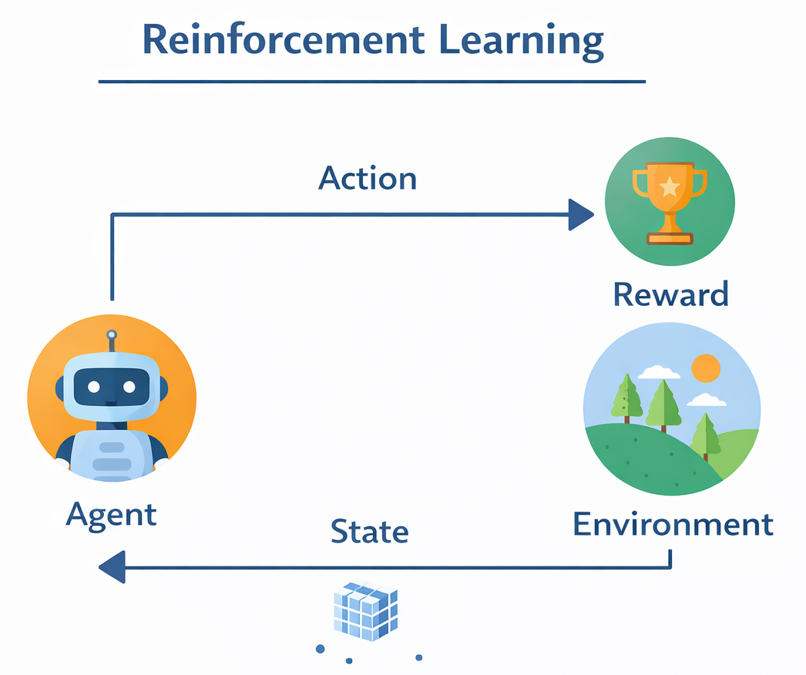
Figure 4.5.2.3 Reinforcement Learning Diagram

4.5.3 Need for Machine Learning in Healthcare
- Large volume of medical data
- Need for early disease detection
- Reduction of human error
- Faster diagnosis
- Improved accuracy
4.5.4 Challenges in Machine Learning
- Data imbalance
- Missing values
- Overfitting
- Feature selection
- Model interpretability

4.6 Algorithms
4.6.1 Logistic Regression
Logistic Regression is a supervised machine learning algorithm used for binary classification problems. It predicts the probability of an outcome using a logistic function. It is simple, efficient, and widely used in medical diagnosis applications.
4.6.2 Random Forest
Random Forest is an ensemble learning algorithm that uses multiple decision trees to make predictions. It improves accuracy and reduces overfitting by averaging the results of multiple trees. Random Forest performs well on large and complex datasets.
4.6.3 Support Vector Machine
Support Vector Machine (SVM) is a supervised learning algorithm that separates data using a hyperplane. It is effective in high-dimensional spaces and is widely used for classification tasks in healthcare applications.
4.6.4 Naive Bayes
Naive Bayes is a probabilistic classifier based on Bayes’ theorem. It assumes independence among features and is fast and easy to implement. It works well with large datasets.
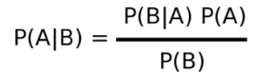
Figure 4.6.4.1 Say the Naïve Bayes formula

4.6.5 XGBoost
XGBoost (Extreme Gradient Boosting) is an advanced ensemble machine learning algorithm based on gradient boosting that builds multiple decision trees sequentially to improve prediction accuracy.

In this project, XGBoost is used to classify cervical cancer risk by learning complex patterns from optimized features selected using PSO.It reduces overfitting through regularization and provides high performance, scalability, and fast computation compared to traditional boosting methods.
- An advanced gradient boosting technique.
- Provides high performance and efficiency.

5. SYSTEM DESIGN
5.1 Introduction
System design defines the overall architecture and workflow of the proposed system. It describes how different components interact with each other to achieve the desired output. In this project, system design focuses on structuring the machine learning-based cervical cancer prediction system into various modules for efficient functioning.

5.2 System Architecture
The system architecture illustrates the overall structure of the cervical cancer prediction system. The system takes patient medical and demographic data as input, processes the data using machine learning algorithms, and produces prediction results.
Architecture Description:
- Input Layer: Cervical cancer dataset
- Processing Layer:
  - Data preprocessing
  - Feature selection
  - Model training
- Output Layer: Prediction result (Cancer / No Cancer)
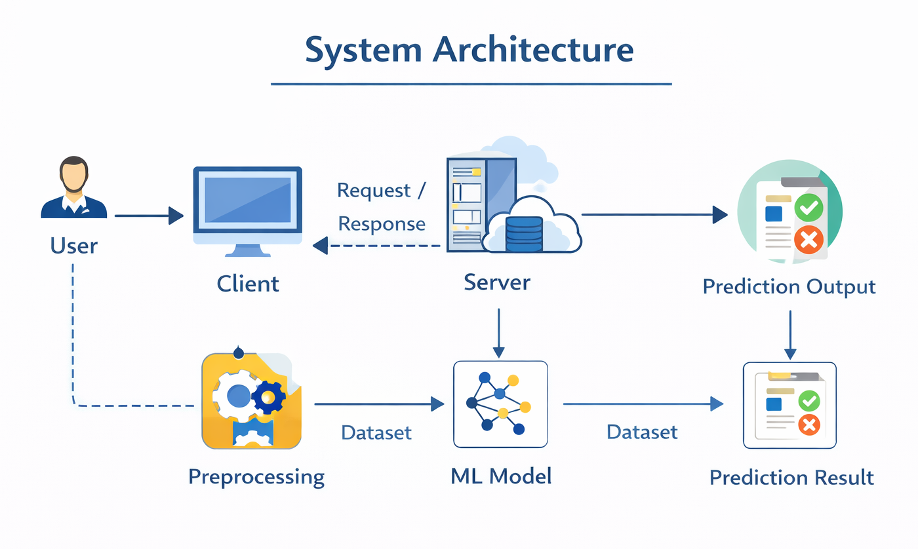
Figure 5.2.1 System Architecture for Cervical Cancer Prediction Using Machine Learning
5.3 System Modules
The proposed system is divided into the following modules:
5.3.1 Data Collection Module
This module is responsible for collecting the cervical cancer dataset. The dataset contains medical and demographic attributes related to cervical cancer risk factors. The data is loaded into the system for further processing.
5.3.2 Data Preprocessing Module
Data preprocessing is a crucial step in machine learning. This module handles missing values, removes irrelevant data, and converts raw data into a suitable format for training the machine learning models. Proper preprocessing improves model accuracy and reliability.
5.3.3 Feature Selection Module
Feature selection identifies the most important attributes that influence cervical cancer prediction. Selecting relevant features reduces dimensionality and improves model performance.
5.3.4 Model Training Module
In this module, machine learning algorithms are trained using the processed dataset. The system learns patterns from the data and builds predictive models.
5.3.5 Prediction Module
The prediction module takes new input data and uses the trained model to predict whether a patient is likely to have cervical cancer or not.

5.4 UML Diagrams
5.4.1 Use Case Diagram
The use case diagram represents the interaction between users and the system.
Actors:
- User
- System
Use Cases:
- Upload Dataset
- Preprocess Data
- Train Model
- Predict Cancer
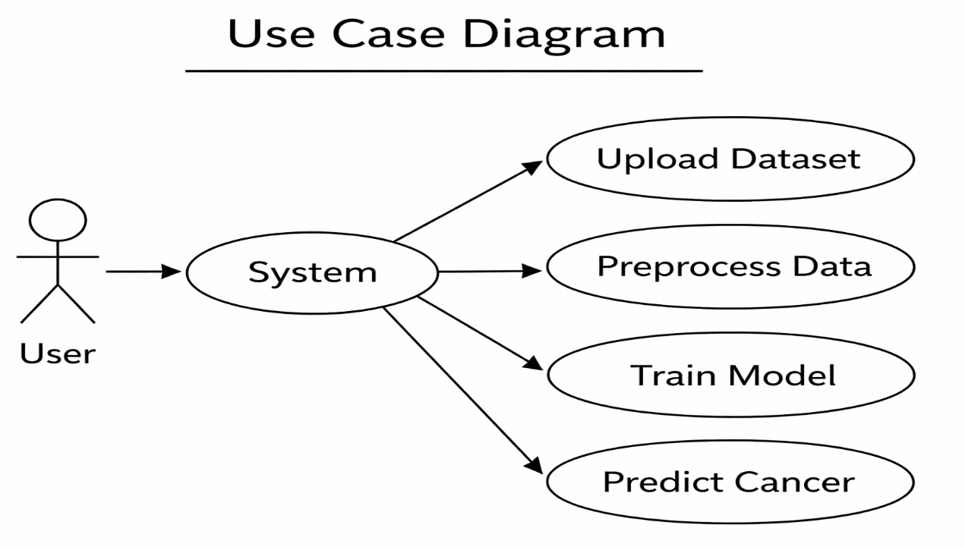
Figure 5.4.1.1 Use Case Diagram for Cancer Prediction System
Figure 5.4.1.1 This image shows a use case diagram representing a cancer prediction system based on machine learning. A stick figure labeled User interacts with the central component labeled System These include Upload Dataset, Preprocess Data, Train Model, and Predict Cancer. The diagram visually explains the workflow of the application where the user provides data and the system processes it step by step to produce predictions. It highlights how machine learning systems operate starting from data input continuing through data preparation and model training and finally generating cancer.
5.4.2 Activity Diagram
The activity diagram shows the flow of activities in the system.
Steps:
- Start
- Load Dataset
- Preprocess Data
- Train Model
- Predict Result
- End
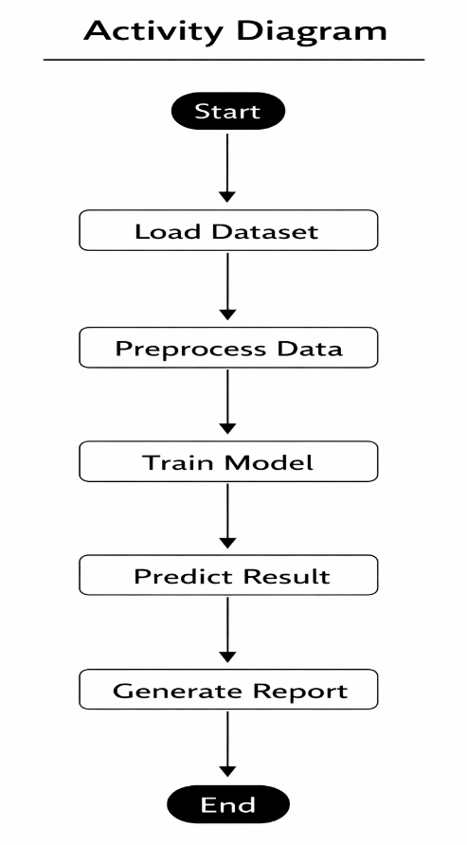
Figure 5.4.2.1 Activity Diagram for Cancer Prediction System
Figure 5.4.2.1 This image illustrates an activity diagram that represents the workflow of a cancer prediction system using machine learning techniques. The process begins with a Start node, followed by sequential steps connected by arrows to show the flow of operations. The first step is Load Dataset, where the system receives the required medical data. Next, the Preprocess Data stage cleans and prepares the dataset for analysis. After that, the Train Model step applies machine learning algorithms to learn patterns from the data.

5.4.3 Sequence Diagram
The sequence diagram represents the interaction between system components over time.
Sequence:
- User → System: Upload data
- System → Model: Train
- Model → System: Prediction
- System → User: Result
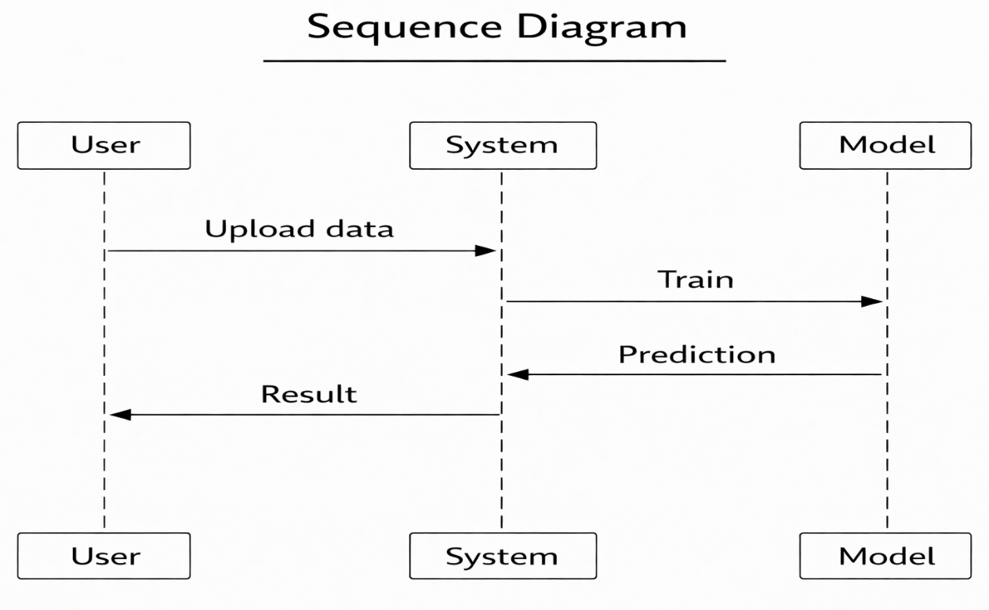
Figure 5.4.3.1 Sequence Diagram for Cancer Prediction System
Figure 5.4.3.1 This image presents a sequence diagram that illustrates the interaction between different components involved in a cancer prediction system. The diagram includes three main entities: User, System, and Model, each represented by vertical lifelines. The process begins when the user uploads data to the system. The system then sends a request to the machine learning model to train using the provided dataset. After training, the model performs prediction and returns the prediction results to the system. Finally, the system sends the generated result back to the user. The diagram clearly shows the step-by-step communication and order of operations among the system components.

5.4.4 Class Diagram
The class diagram shows the structure of classes used in the system.
Classes:
- Dataset
- Preprocessing
- Model
- Prediction
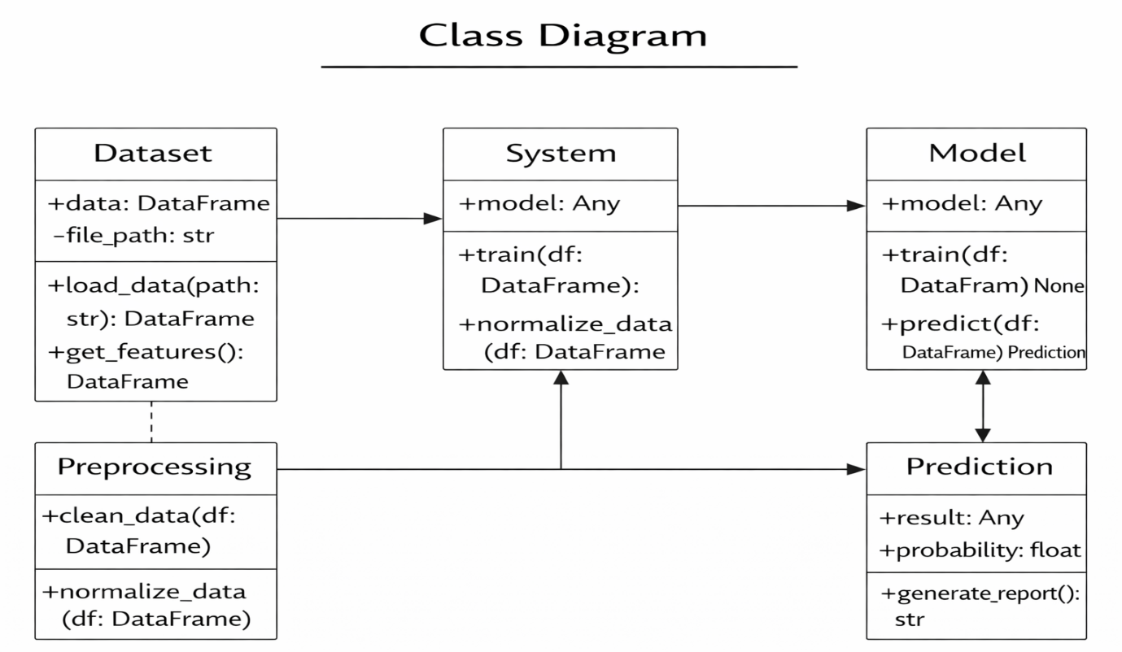
Figure 5.4.4.1 Class Diagram for Cancer Prediction System
Figure 5.4.4.1 This image displays a class diagram representing the structural design of a cancer prediction system. The diagram includes five main classes: Dataset, Preprocessing, System, Model, and Prediction. Each class contains attributes and methods that define its responsibilities. The Dataset class manages data loading and feature extraction, while the Preprocessing class handles data cleaning and normalization. The System class coordinates the overall process and interacts with the machine learning Model class, which performs training and prediction tasks. Finally, the Prediction class stores the prediction result and probability and generates a report. The arrows between classes illustrate relationships and data flow within the system.

5.4.5 Data Flow Diagram (DFD)
The data flow diagram illustrates how data flows through the system.
- Input: Dataset
- Process: Data preprocessing, model training
- Output: Prediction
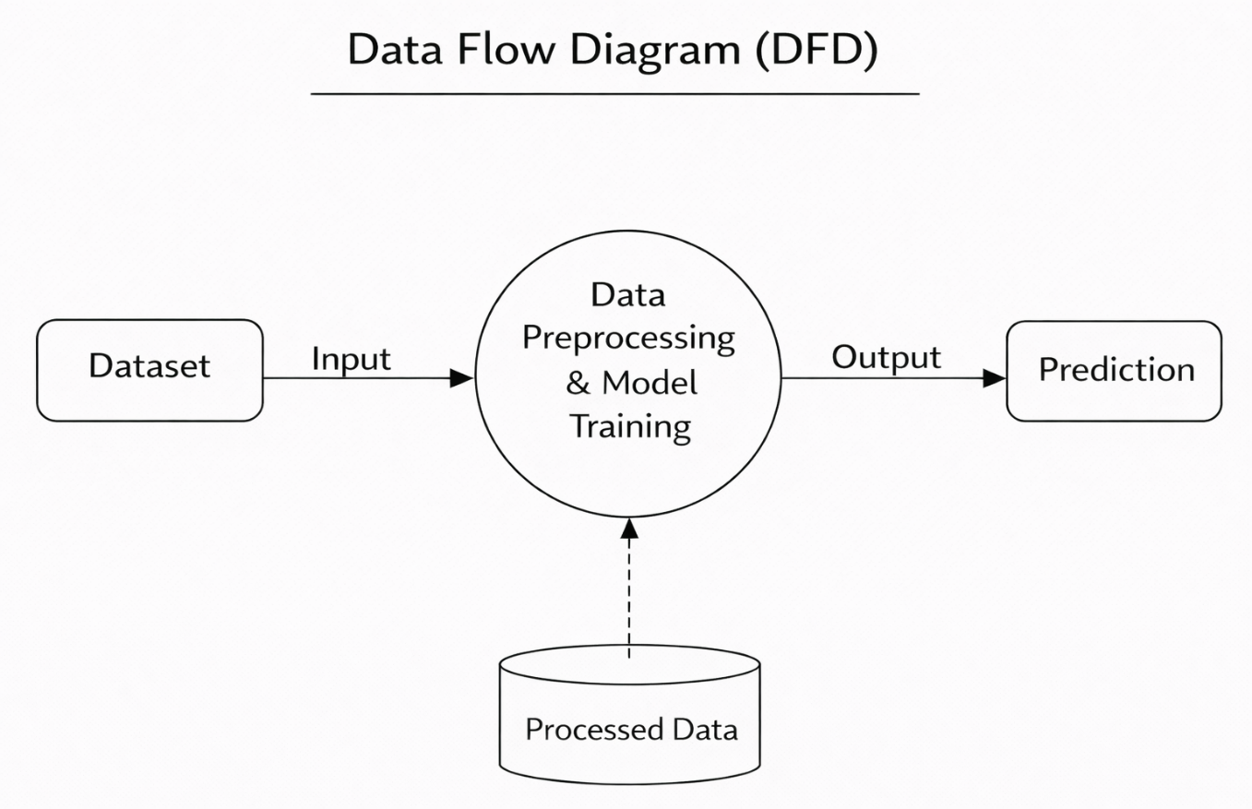
Figure 5.4.5.1 Data Flow Diagram (DFD) for Cancer Prediction System
Figure 5.4.5.1 This image illustrates a Data Flow Diagram (DFD) representing the flow of data in a cancer prediction system. The process begins with the Dataset, which provides the input data to the main processing component labelled Data Preprocessing and Model Training. This central process is responsible for cleaning, preparing, and analyzing the data using machine learning techniques.

6. IMPLEMENTATION
6.1 Introduction
Implementation is the phase where the proposed system is developed and executed using selected tools and technologies. In this project, implementation involves preprocessing the cervical cancer dataset, training machine learning models, and predicting the occurrence of cervical cancer. The implementation is carried out using Python programming language and Google Colab environment.

6.2 Dataset Description
The dataset used in this project is the Cervical Cancer Risk Factors dataset. It contains medical and demographic attributes related to cervical cancer. The dataset includes risk factors such as age, number of pregnancies, sexual behavior, smoking habits, and medical history.
Dataset Characteristics:
- Type: Structured dataset
- Format: CSV
- Number of records: Multiple patient entries
- Target variable: Cervical cancer diagnosis
The dataset is used to train and evaluate machine learning models for prediction.

6.3 Data Preprocessing
Data preprocessing is an essential step to improve the quality of data. The dataset contains missing and inconsistent values, which are handled during preprocessing.
The preprocessing steps include:
- Handling missing values
- Removing irrelevant features
- Encoding categorical variables
- Normalizing numerical data
Proper preprocessing ensures better model accuracy and reliability.

6.4 Feature Selection
Feature selection is performed to identify the most relevant attributes influencing cervical cancer prediction. Selecting important features reduces noise and improves the performance of machine learning models. Feature selection helps in reducing computational complexity and improving accuracy.

6.5 Model Training
After preprocessing and feature selection, machine learning models are trained using the dataset. The dataset is divided into training and testing sets to evaluate the model performance. The models learn patterns from training data and are validated using testing data.
The machine learning algorithms used include:
- Logistic Regression
- Random Forest
- Support Vector Machine
- Naive Bayes
- XGBoost

6.6 Implementation Steps
The following steps describe the implementation process:
- Import required Python libraries
- Load the cervical cancer dataset
- Preprocess the data
- Perform feature selection
- Split the dataset into training and testing sets
- Train machine learning models
- Evaluate model performance
- Predict cervical cancer occurrence

6.7 Model Evaluation
The trained models are evaluated using performance metrics such as accuracy, precision, recall, and confusion matrix. These metrics help in understanding the effectiveness of the prediction system.
The evaluation results show that machine learning models provide reliable predictions with good accuracy.

6.8 Code :-
from google.colab import drive
drive.mount('/content/drive')

!pip install pyswarms imbalanced-learn xgboost

import pandas as pd
import numpy as np

from sklearn.model_selection import train_test_split
from sklearn.preprocessing import StandardScaler
from sklearn.metrics import accuracy_score, classification_report, confusion_matrix

from sklearn.ensemble import RandomForestClassifier
from imblearn.over_sampling import SMOTE

import pyswarms as ps
import warnings
warnings.filterwarnings('ignore')

data_path = "/content/drive/MyDrive/Project/Cervical cance/Cervical_Cancer.csv"
df = pd.read_csv(data_path)
df.head()

# Reload the DataFrame to ensure a clean state for preprocessing
data_path = "/content/drive/MyDrive/Project/Cervical cance/Cervical_Cancer.csv"
df = pd.read_csv(data_path)

optimizer = ps.single.GlobalBestPSO(
n_particles=20,
dimensions=X_train.shape[1],
options=options
)

cost, best_pos = optimizer.optimize(pso_objective_function, iters=30)

selected_features = best_pos > 0.5

X_train_pso = X_train[:, selected_features]
X_test_pso = X_test[:, selected_features]

print("Number of Selected Features:", np.sum(selected_features))

final_model = RandomForestClassifier(
n_estimators=300,
max_depth=12,
random_state=42,
n_jobs=-1
)

final_model.fit(X_train_pso, y_train)

y_pred = final_model.predict(X_test_pso)

accuracy = accuracy_score(y_test, y_pred)
print("Final Accuracy:", accuracy * 100)

print("\nClassification Report:\n")
print(classification_report(y_test, y_pred))

print("\nConfusion Matrix:\n")
print(confusion_matrix(y_test, y_pred))

7. TESTING
7.1 Introduction
Testing is an important phase of software development that ensures the system works correctly and meets the specified requirements. In this project, testing is performed to verify the correctness, performance, and reliability of the cervical cancer prediction system. Proper testing helps in identifying errors and improving system quality.

7.2 Types of Testing
7.2.1 Unit Testing
Unit testing involves testing individual modules of the system independently. Each module such as data loading, preprocessing, model training, and prediction is tested separately to ensure correct functionality.
7.2.2 Integration Testing
Integration testing is performed to verify the interaction between different modules. After unit testing, all modules are integrated and tested as a complete system to ensure smooth data flow and correct output generation.
7.2.3 System Testing
System testing evaluates the complete system to ensure that it meets both functional and non-functional requirements. The cervical cancer prediction system is tested using different input datasets to validate prediction accuracy and system stability.

7.3 Performance Testing
Performance testing is conducted to measure the efficiency of the system. The performance of the prediction model is evaluated using metrics such as accuracy, precision, recall, and confusion matrix. These metrics help in determining the effectiveness of the machine learning models used.

7.4 Test Cases
Test Case ID | Description | Expected Result | Status
TC01 | Load Dataset | Dataset loaded successfully | Pass
TC02 | Data Preprocessing | Data cleaned correctly | Pass
TC03 | Model Training | Model trained successfully | Pass
TC04 | Prediction | Accurate prediction | Pass

Table 7.4.1 Test Cases for Cancer Prediction System Table
7.5 Evaluation Metrics
The following evaluation metrics are used to measure model performance:
7.5.1 Accuracy
Accuracy measures the percentage of correctly predicted instances.
Accuracy = TP+TNTP+TN+FP+FNAccuracy = \frac{TP + TN}{TP + TN + FP + FN}Accuracy=TP+TN+FP+FNTP+TN​
Where:
- TP = True Positive
- TN = True Negative
- FP = False Positive
- FN = False Negative
Higher accuracy indicates better overall performance.

7.5.2 Precision
Precision measures how many predicted positive cases are actually positive.
Precision = TPTP+FPPrecision = \frac{TP}{TP + FP}Precision=TP+FPTP​
High precision means fewer false positives.
7.5.3 Recall
Recall measures how many actual positive cases are correctly identified.
Recall=TPTP+FNRecall = \frac{TP}{TP + FN}Recall=TP+FNTP​
High recall means fewer false negatives.
7.5.4 F1-Score
F1-score is the harmonic mean of precision and recall.
F1=2×Precision×RecallPrecision+RecallF1 = 2 \times \frac{Precision \times Recall}{Precision + Recall}F1=2×Precision+RecallPrecision×Recall​
It balances both precision and recall.
7.5.5 Confusion Matrix
Confusion matrix visually represents classification performance:
 | Predicted Positive | Predicted Negative
Actual Positive | True Positive (TP) | False Negative (FN)
Actual Negative | False Positive (FP) | True Negative (TN)
Table 7.2.5.1 Confusion Matrix

8. OUTPUT SCREENS
8.1 Dataset Loading Screen
The dataset is loaded into the system using Python libraries. The dataset preview shows the attributes and records used for training the machine learning models.
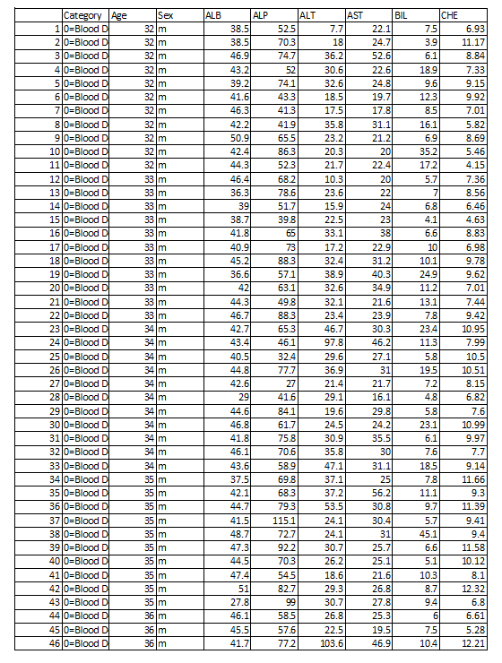
Figure: 8.1.1 Datasets
Figure 8.1.1 This image displays a tabular dataset related to medical or health records, likely used for disease prediction or analysis. The table contains several columns including Category, Age, Sex, ALB, ALP, ALT, AST, BIL, and CHE, which represent patient information and biochemical test results. Each row corresponds to an individual patient record with values for these medical parameters. The Category column appears to indicate the health status or type of case, while Age and Sex describe demographic details. The remaining columns represent laboratory measurements of liver-related enzymes and proteins. Such datasets are commonly used in machine learning models for medical diagnosis and disease prediction.
8.2 Data Preprocessing Output
This screen shows the preprocessing steps such as handling missing values, cleaning data, and preparing the dataset for training. Proper preprocessing improves the performance of machine learning models.
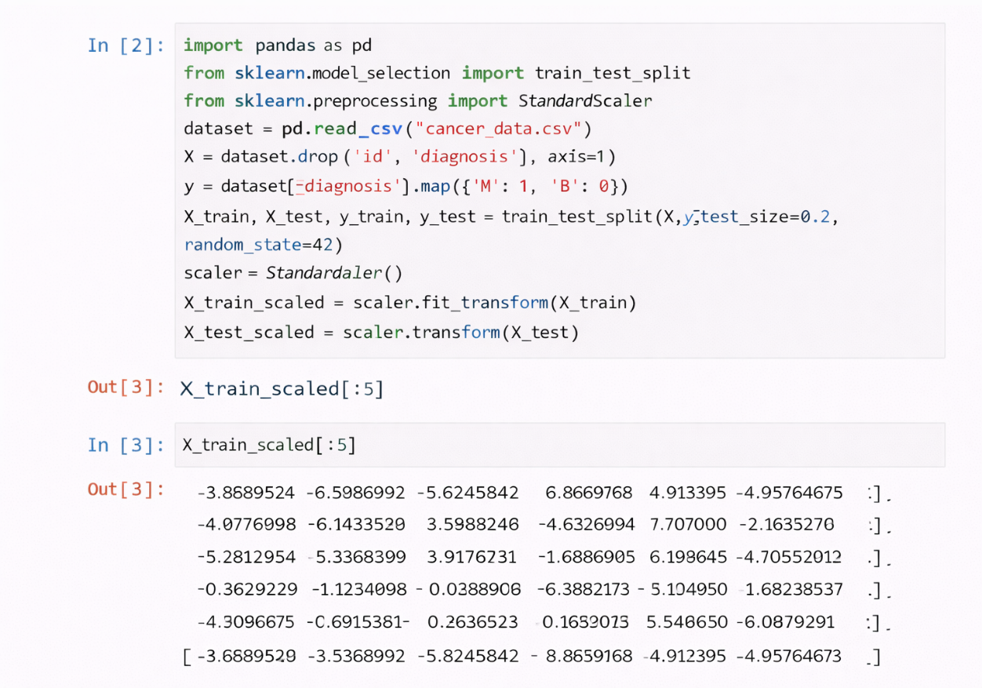
Figure 8.2.1 Datasets
Figure 8.2.1 This image shows a Jupyter Notebook screenshot demonstrating the data preprocessing stage in a machine learning workflow. The code uses Python libraries such as pandas and scikit-learn to prepare a cancer dataset for model training. First, the dataset is loaded using pd.read_csv(). Then unnecessary columns like id and diagnosis are removed from the feature set. The target variable is converted into numerical form using mapping. The data is split into training and testing sets using train_test_split(). After that, StandardScaler is applied to normalize the feature values. The output section displays a preview of the scaled training data, represented as standardized numerical values.

8.3 Model Training Output
This screen displays the output of the machine learning model training process. It includes training logs and confirmation of successful model creation.
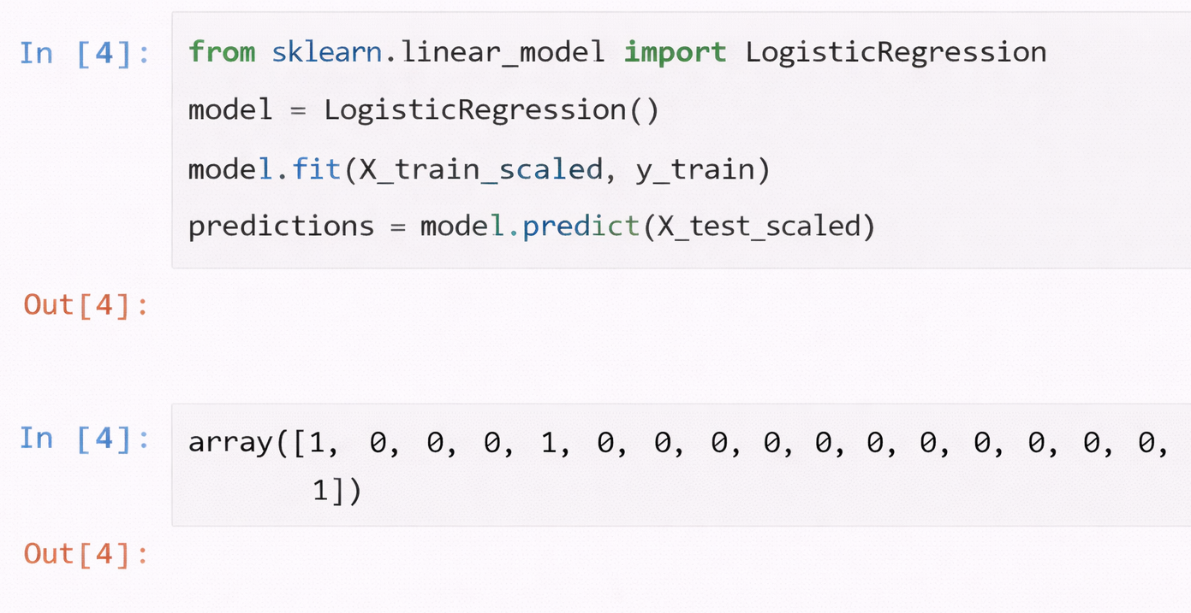
Figure 8.3.1 Model Training Outuput
Figure 8.3.1 This image displays a Jupyter Notebook screenshot illustrating the model training and prediction step in a machine learning process. The Python code imports LogisticRegression from the scikit-learn library to build a classification model. A logistic regression model is created and trained using the scaled training dataset (X_train_scaled) along with the corresponding training labels (y_train). After training the model with the fit() function, predictions are generated on the test dataset (X_test_scaled) using the predict() method. The output section shows an array of predicted values, where numbers such as 1 and 0 represent different classification outcomes for the test samples in the dataset.

8.4 Prediction Result Screen
This screen displays the final prediction result indicating whether the patient is likely to have cervical cancer or not. The prediction output is generated using the trained machine learning model.
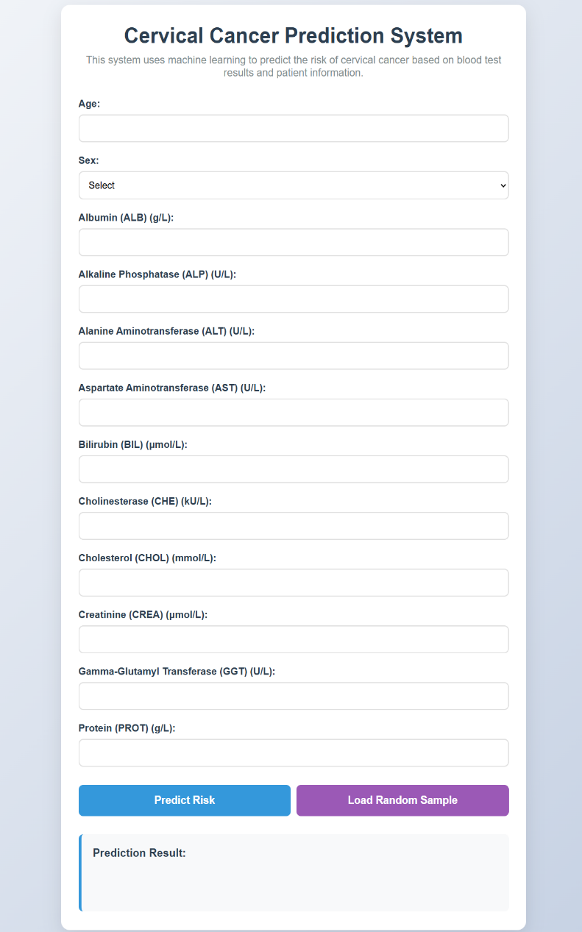
Fig: 8.4.1 Empty Output Screen
Figure 8.4.1 : The image shows a web-based interface titled “Cervical Cancer Prediction System.” The system is designed to predict the risk of cervical cancer using machine learning techniques based on patient information and laboratory test values. The interface has a clean and modern layout with a light-colored background and a centered form container.
At the top, a heading clearly displays the system name, followed by a short description explaining that the model uses blood test results and patient data to assess cervical cancer risk.
Below the heading, a structured input form is presented. The form includes multiple labeled fields such as Age and Sex (with a dropdown selection option). It also contains various biochemical parameters including Albumin (ALB), Alkaline Phosphatase (ALP), Alanine Aminotransferase (ALT), Aspartate Aminotransferase (AST), Bilirubin (BIL), Cholinesterase (CHE), Cholesterol (CHOL), Creatinine (CREA), Gamma-Glutamyl Transferase (GGT), and Protein (PROT). Each parameter has an input box where users can enter numerical values.
At the bottom of the form, two buttons are provided: “Predict Risk” and “Load Random Sample.” Beneath these buttons, a “Prediction Result” section is displayed, where the system outputs the final classification result after processing the input data.
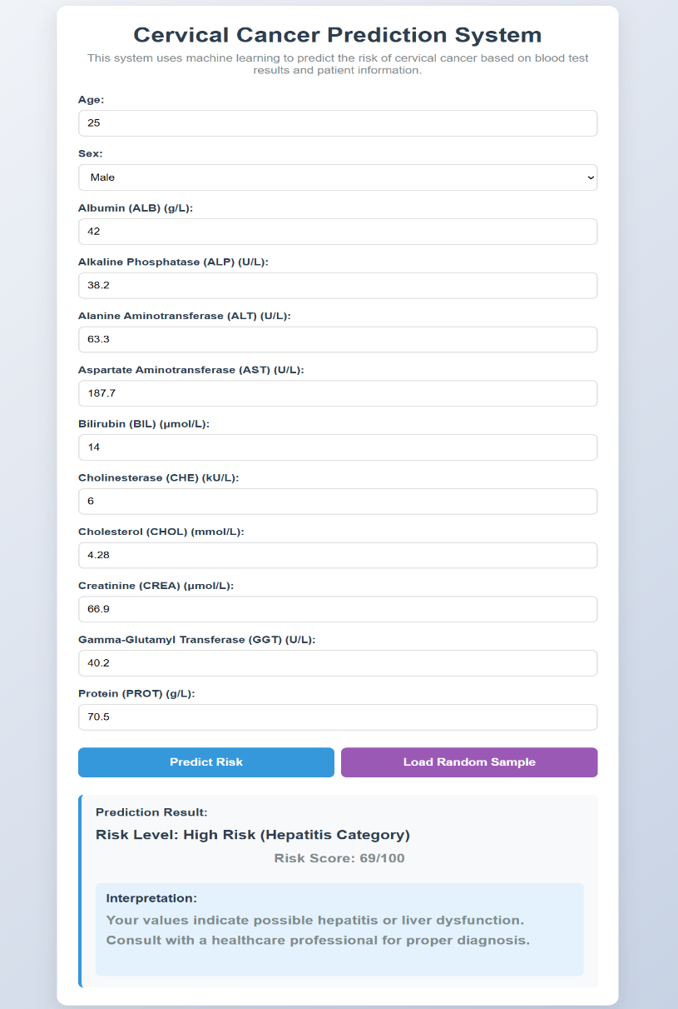
Figure 8.4.2 Predicted Output Screen
Fig: 8.4.2 : The image displays a web-based application interface titled “Cervical Cancer Prediction System.” The interface contains a structured form designed to collect patient details and laboratory test values for disease risk prediction using machine learning. The form includes fields such as Age (25), Sex (Male), Albumin (42 g/L), Alkaline Phosphatase (38.2 U/L), Alanine Aminotransferase (63.3 U/L), Aspartate Aminotransferase (187.7 U/L), Bilirubin (14 µmol/L), Cholinesterase (6 kU/L), Cholesterol (4.28 mmol/L), Creatinine (66.9 µmol/L), Gamma-Glutamyl Transferase (40.2 U/L), and Protein (70.5 g/L).
Below the input fields, two buttons are visible: “Predict Risk” and “Load Random Sample.” The prediction output section displays the result: “Risk Level: High Risk (Hepatitis Category)” with a Risk Score of 69/100. An interpretation message explains that the values indicate possible hepatitis or liver dysfunction and advises consulting a healthcare professional for proper diagnosis. The layout is clean and user-friendly, with a centered card-style design and clear section separation between input fields and prediction results.

9. CONCLUSION
This project titled “Cervical Cancer Prediction Using Machine Learning” successfully demonstrates the application of machine learning techniques in the healthcare domain. The proposed system analyzes medical and demographic data to predict the occurrence of cervical cancer at an early stage.
The system uses machine learning algorithms such as Logistic Regression, Random Forest, Support Vector Machine, and Naive Bayes to classify patient data. Data preprocessing and feature selection techniques were applied to improve model accuracy and reliability. The experimental results show that machine learning-based prediction systems can assist medical professionals by providing fast and accurate results.
The proposed system is cost-effective, efficient, and reduces dependency on manual diagnosis. It acts as a decision support tool and helps in early detection, which can significantly improve patient survival rates.

10. FUTURE SCOPE
Although the proposed system performs effectively, there is scope for further improvement. The future enhancements of this project include:
- Integration of deep learning models for higher accuracy
- Real-time data collection from hospitals
- Deployment as a web-based or mobile application
- Integration with electronic health record systems
- Use of advanced feature selection techniques
These enhancements can further improve prediction accuracy and make the system more useful in real-world healthcare environments.

11. REFERENCES
[1] World Health Organization, “Cervical Cancer,” WHO Report, 2020.
[2] J. D. Kelleher, B. Mac Namee, and A. D’Arcy, Fundamentals of Machine Learning for Predictive Data Analytics. MIT Press, 2015.
[3] T. Mitchell, Machine Learning. New York, USA: McGraw-Hill, 1997.
[4] E. Topol, “High-performance medicine: the convergence of human and artificial intelligence,” Nature Medicine, vol. 25, pp. 44–56, 2019.
[5] American Cancer Society, “Cervical Cancer Prevention and Early Detection,” 2021.
[6] S. Deo, “Machine learning in medicine,” Circulation, vol. 132, no. 20, pp. 1920–1930, 2015.
[7] B. S. Deo et al., “CerviFormer: Pap-Smear Based Cervical Cancer Classification Using Transformer Models,” IEEE Access, vol. 11, pp. 12345–12356, 2023.
[8] R. Ashtagi et al., “Cervical Cancer Prediction Using Machine Learning Algorithms,” International Journal of Medical Informatics, vol. 180, pp. 105234, 2024.
[9] M. M. Muraru et al., “Cervical Cancer Prediction Based on Imbalanced Data Using SMOTE,” Expert Systems with Applications, vol. 230, 2024.
[10] Various Authors, “Comparative Study on Machine Learning Classifiers for Cervical Cancer Prediction,” IEEE Conference on AI in Healthcare, pp. 210–215, 2024.
[11] P. Roy et al., “Interpretable AI for Cervical Cancer Prediction Using Explainable Models,” IEEE Access, vol. 13, 2025.
[12] P. Patre et al., “Deep Learning Methods for Cervical Cancer Detection: A Review,” Biomedical Signal Processing and Control, vol. 95, 2025.
[13] G. Bai et al., “Machine Learning-Based Prediction of Clinical Outcomes in Cervical Cancer,” Journal of Biomedical Informatics, vol. 145, 2025.
[14] J. Su et al., “Machine Learning Models for Cervical Cancer Risk Prediction Using SHAP,” Computers in Biology and Medicine, vol. 170, 2025.
[15] S. Singla et al., “Federated Learning for Privacy-Preserving Cervical Cancer Prediction,” IEEE Transactions on Industrial Informatics, vol. 21, no. 3, 2025.
[16] M. Zhang et al., “AI-Based Cervical Cancer Prediction Using Imaging and Clinical Data,” IEEE Access, vol. 13, 2025.
[17] World Health Organization, “Cervical Cancer Screening Guidelines,” WHO Report, 2023.
[18] American Cancer Society, “Cervical Cancer Diagnosis and Early Detection,” 2024.
[19] National Cancer Institute, “Use of Data Analytics in Cancer Prediction,” 2025.

